Potential Structure, however please feel free to adapt it
(Please refer “Download File 2”)
- Title (up to 10 words)
- Abstract ( up to 100 words)
- Introduction (around 300-500 words)
- Main Body (The remainder around 3500 to 4000 words)
- Conclusions (around 500-1000 words)
- Total 5000-5500 words.

- Title (up to 10 words) & Abstract ( up to 100 words)
- A clear specific and focused title
- The abstract – a clear short summary of what you have investigated and how.
- A list of key words (terms) e.g. Absenteeism, Nursing , NHS, management, best practice
- Introduction (around 300-500 words)
- Purpose of the work and some “signposting” around the structure of the assignment
- Focus of Research, Research Boundaries (Including inclusion/exclusion criteria)
- Clear justification(s) for the importance of the work (Scale of NHS nurse absenteeism (is it a crisis?), showing that nurse absenteeism rates are higher than one would expect (e.g. public vs private sector etc.), costs (financial and impact on patient care etc., quotes from key stakeholders (e.g. Government ministers etc.) (Draw on “good” news papers, academic journal relating to UK nursing, and Professional bodies such as the Royal College of Nursing.
- Indications (Maybe) from the academic literature (Scholar Google) around the currency of the topic under investigation
- Main Body (The remainder around 3500 to 4000 words)
- Introduction of key construct(s) such as absenteeism, including direct quotes
- The identification of extant literature linked to the assignment title and key words.
- The identification of seminal writers, theories models and frameworks (including diagrams linking key constructs along with their discussion)
- Identification of areas of agreement and disagreement (e.g. Hofstede versus McSweeney on National culture), the uncritical use of theories “given to you” in level 4 and 5 study such as Maslow and Herzberg on motivation will lead to a reduced mark. Better students ask questions such as are these theories gendered? Are these theories appropriate for studying nurses, are there more recent theories around human workplace (and specifically nursing) based motivation (yes there is!)
- Will identify that “real” organisation (including the NHS) have done to minimize (unjustified) and produce a synthesis of academic theory and professional practice (e.g. professional HRM staff in the NHS).
- Conclusions (around 500-1000 words)
- A short summary of key findings (e.g. tensions/agreements in the academic literature), the relationship between academic theory and current professional practice (e.g. do they agree, if not what are the differences etc?)
- What should HRM professional (particularly those managing NHS nursing) staff do to ensure that their management systems around absenteeism are comparable with the very best organisations (i.e. “best practice”)?
For the main body flow as below:-
- Explanations of this model https://scholar.google.com.hk/scholar?hl=zh-TW&as_sdt=0%2C5&q=Extending+the+four-stage+brand+loyalty+framework+in+African+Telecoms&btnG=
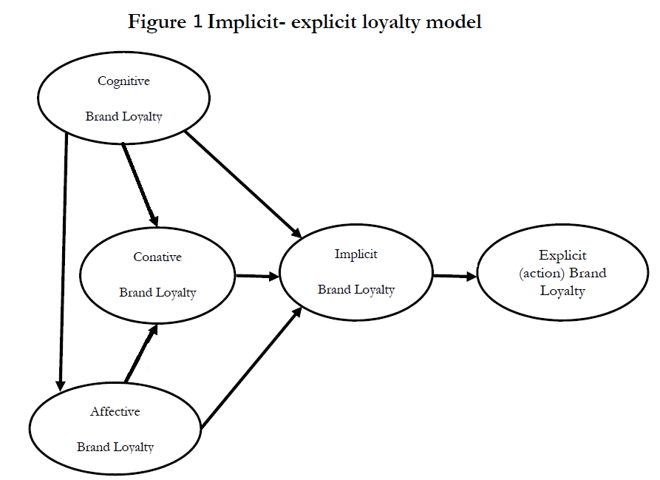
(source: ……) please use APA format, thanks!
- Explanations that after research show that the sequence is Cognitive brand loyalty> Affective Brand Loyalty>Conative Brand Loyalty (please help to find the sources for support and no need put the model in the assignment)
- Explanations that after research show that Customer satisfaction, customer delight are influencing Cognitive brand loyalty> Affective Brand Loyalty>Conative Brand Loyalty (please help to find the sources for support and no need put the model in the assignment)
- Finally, theoretical framework of this study as below
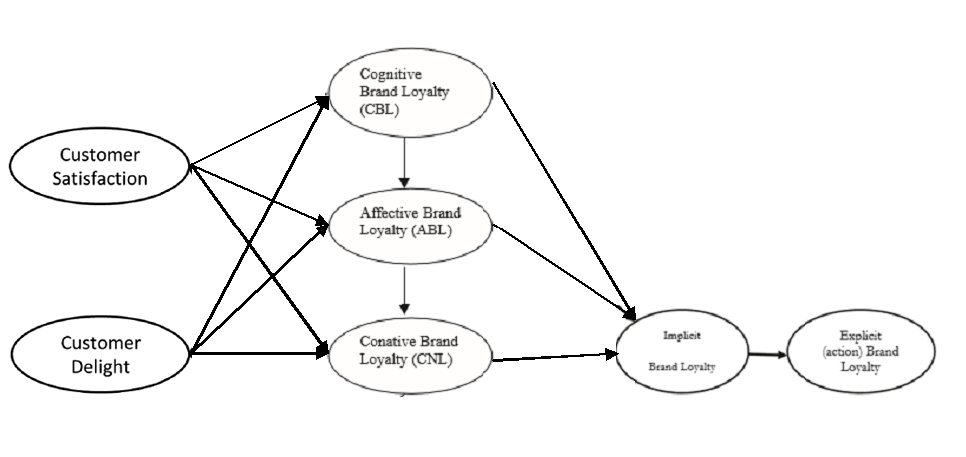
(source:….please use APA format, thanks)
- To identify each items as from customer satisfaction, customer delight, cognitive brand loyalty….to Explicit (action) brand loyalty
- After that is Best Practice>conclusion>limitation and further research
Please follow up the assignment briefing word counts to do this assignment, E.g. Abstract ( up to 100 words) …many thanks!

----------------------
Amendment:
- The number of “1.0” change to be “1, 2, 3…”etc. and 1.1, 1.2..etc.

